 | 7.1.22 Editors - 3D Viewport - Header - Mesh - Texture Paint mode - Brush menu
Table of content
Texture Paint Mode - Brush Menu 1
Color Picker 1

Texture Paint Mode - Brush Menu
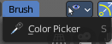
With texture mapping type stencil you will see the navigation controls to navigate the stencil map. Same for the texture mask mapping type stencil. These navigation types are hotkey only tools.

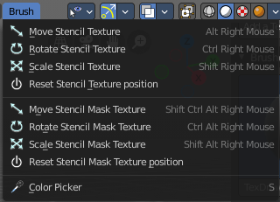
Color Picker
Allows you to pick a color in the 3D view. Hotkey tool!

Move, Rotate Scale Stencil Texture.

